
TYPE 1
DIABETES:
WHATTO DO
WHEN YOU
ARE ILL


- WHY IS THIS LEAFLET FOR YOU?

Everyone has days when they are not well. If you have diabetes, being unwell can affect your glucose control so it is important that you know how to manage this. This leaflet will give you essential information on:

- How illness affects your glucose levels

- Looking after yourself

- Managing your insulin

- What to eat and drink

- Being prepared

• When to seek help

Date of preparation: March 2020

The content of this leaflet was generated independently by TREND-UK. Printing and distribution was funded by Novo Nordisk

- HOW DOES ILLNESS AFFECT YOUR GLUCOSE LEVELS?

When you are ill, especially if you have an infection and high temperature, your body is less responsive to the insulin you inject. Insulin is a hormone which controls your glucose level. Being unwell therefore usually makes your glucose levels rise, even if you are eating less than usual.

You can also produce ketones when you are unwell. These are produced when the body is unable to use glucose for energy.
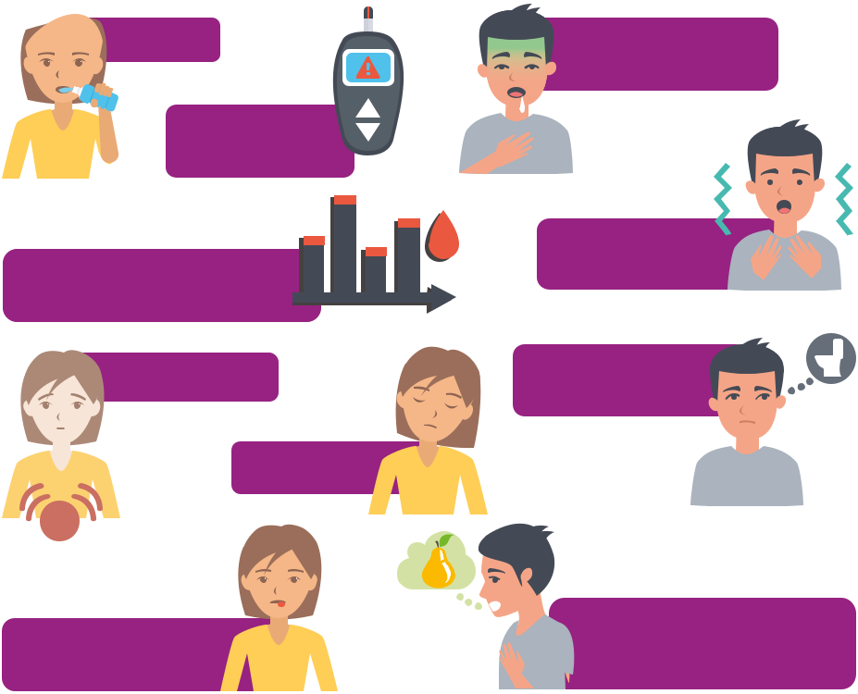

Thirst

High blood

glucose levels

Ketones in the blood

higher than 3.0 mmol/L

Stomach pain

Drowsiness

Sweet or metallic

taste in the mouth

Feeling and/or

being sick

Fast and deep

breathing

Passing more

urine than usual

Others may notice your breath smells of acetone or pear-drops

It is possible to manage your diabetes effectively during illness, keep your glucose levels in or near to target, and prevent the development of ketones by following the simple advice given in this leaflet.


2



- LOOKING AFTER YOURSELF

- Rest: avoid strenuous exercise

- Prevent dehydration by drinking plenty of sugar-free fluids. Sip gently

throughout the day (at least 2 ½ to 3 ½ litres or 4 to 6 pints in 24 hours)

- Treat symptoms such as a high temperature or a cough with basic

over-the-counter medicines such as painkillers and cough syrups. These do not have to be sugar-free varieties as they contain very little glucose and are taken in small quantities. Ask your pharmacist for advice

- Contact your GP if you think you have an infection as you may

need antibiotics

( Monitor your glucose levels by your usual method e.g. capillary glucose or continual interstitial glucose monitoring while

you feel unwell. Test your blood/urine for ketones ( Understanding your blood ketone levels:

- Less than 0.6 mmol/L is normal

- 0.6 to 1.5 mmol/L means you may be at risk of developing DKA so test again after 2 hours
- 1.6 to 2.9 mmol/L means you are at risk of DKA and should contact your diabetes team or GP as soon as possible
- 3 mmol/L or higher means you have a very high risk of DKA and should get emergency help as soon as possible

If you are only able to do a urine ketone test, a result of 2+ means you may be at risk of developing DKA.

You may need to adjust your insulin dose while you are ill, especially if your glucose level is high and you develop ketones.

Seek urgent medical help if your readings remain higher than usual, or you feel very unwell and you are not sure what to do.

3

- MANAGING YOUR INSULIN DOSE WHEN YOUR BLOOD KETONES ARE LESS THAN 1.5 MMOL/L
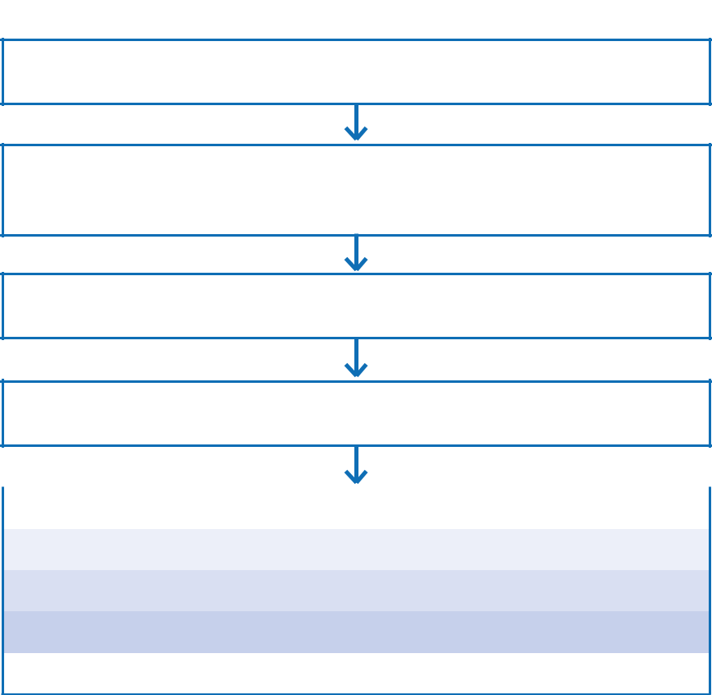

Glucose more than 11 mmol/L and/or you feel unwell, either with no ketones or blood ketones less than 1 . 5 mmol/L (negative or trace of urine ketones)

Sip sugar-free fluids, at least 100 ml/hr. Eat as normal if possible. If not, see meal replacement suggestions (page 6). You need food containing carbohydrate (carbs), insulin and fluids to avoid dehydration and prevent diabetic ketoacidosis

Test glucose and blood ketones

every 4 to 6 hours including during the night

Aim to take your usual insulin dose. However, if your glucose

is above 11 mmol/L, take additional insulin as below

 | Glucose | Insulin dose
11 | – 17 mmol/L | Add 2 extra units to each dose
17 | – 22 mmol/L | Add 4 extra units to each dose
More than 22 mmol/L |  | Add 6 extra units to each dose

Call your GP or nurse if your glucose still remains higher than normal

- If you start vomiting, are unable to keep fluids down, or are unable to control your glucose or ketone levels, you must seek urgent medical advice. DON’T

STOP TAKING YOUR INSULIN EVEN IF YOU ARE UNABLE TO EAT


4

- MANAGING YOUR INSULIN DOSE WHEN YOUR BLOOD KETONES ARE 1.5 MMOL/L OR HIGHER


Glucose more than 11 mmol/L and/or you feel unwell, either with blood ketones 1 . 5 mmol/L or higher (+ or more of urine ketones)

Sip sugar-free fluids, at least 100 ml/hr. Eat as normal if possible. If not, see meal replacement suggestions (page 6). You need food containing carbohydrate (carbs), insulin and fluids to avoid dehydration and prevent diabetic ketoacidosis

1 . 5 to 3 mmol/L on blood ketone meter |  |  |  |  | More than 3 mmol/L on blood ketone
(+ to ++ urine ketones) |  |  |  |  |  | meter (+++ to ++++ urine ketones)
Give an additional 10% of |  | Total daily |  |  |  |  | Give an additional 20% of
your TDD as rapid-acting or |  | insulin |  |  |  |  | your TDD as rapid-acting or
mixed insulin every 2 hours |  | dose: TDD |  |  |  |  | mixed insulin every 2 hours
1 unit |  | Up to 14 units |  |  |  |  |  | 2 units
2 units |  | 15 to 24 units |  |  |  |  |  | 4 units
3 units |  | 25 to 34 units |  |  |  |  |  | 6 units
4 units |  | 35 to 44 units |  |  |  |  |  | 8 units
5 units |  | 45 to 54 units |  |  |  |  | 10 units
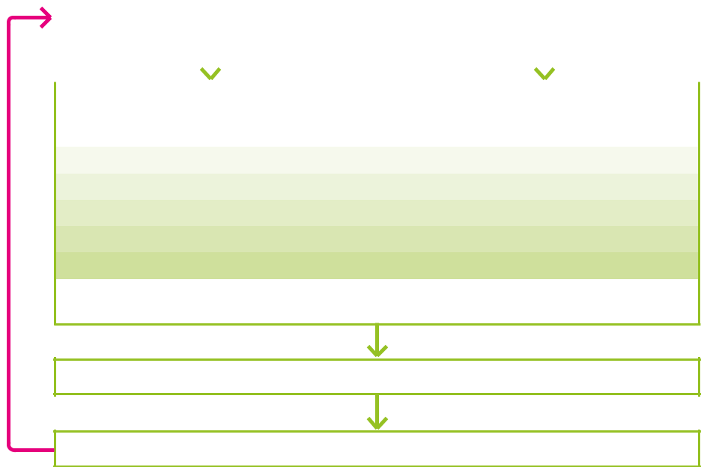

If you take more than 54 units or if you are unsure how to

alter your dose, contact your specialist team or GP

Test glucose and blood ketones every 2 hours including during the night

Glucose more than 11 mmol/L and ketones present?

YES - REPEAT PROCESS  NO

As your illness resolves, adjust your insulin dose back to normal)

- If you start vomiting, are unable to keep fluids down, or are unable to control your glucose or ketone levels, you must seek urgent medical advice. DON’T

STOP TAKING YOUR INSULIN EVEN IF YOU ARE UNABLE TO EAT

5

- WHAT CAN YOU EAT AND DRINK?

Your body uses a lot of energy when you are unwell, even if you are resting. Try to eat as normal but if you cannot manage your usual meals, replace these with light and easily digested foods such as soups and milky puddings. See the table below for a list of alternative food options. Each

portion is equal to approximately 10 gram carbohydrate (e.g. an egg-
size potato, a small slice of bread or a tablespoon of cooked rice or pasta):


Fruit juice

100 ml

Milk

200 ml

Plain vanilla ice-cream

1 large scoop
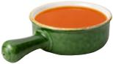

Tomato soup

200 gram (half a large tin)


Low fat yoghurt

150 gram (1 small pot)

2 Rich tea or malted milk biscuits

6

- WHEN TO SEEK HELP

Get to hospital urgently if any of these apply to you:

- If you are pregnant and have ketones

- If you vomit for the duration of 2 meals (i.e. 4 hours) and are unable to keep fluids down

- If you have persistent ketones despite increasing your insulin

- If you become drowsy and/or breathless

- If you have acute abdominal pain

- If your condition worsens despite following the advice given in this leaflet

If you need to go to hospital, remember to take a list of all your medications and insulin safety card with you

- Even if you are not eating, never stop your insulin
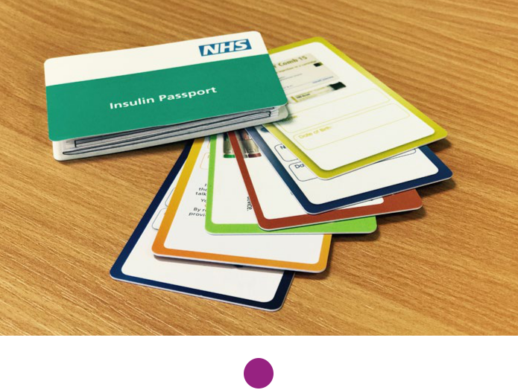

7

- BEING PREPARED:


- Make sure you always have plenty of insulin and glucose and ketone monitoring equipment available

- Make sure your ketone strips are still in date if you have not used them for a while

- Keep a few simple medicines such as painkillers and cough syrup

in a safe place in the house

- Discuss how to manage your diabetes when you are unwell with your doctor or nurse so you know what to do if you become ill and know when to seek help

- USEFUL RESOURCES:

TREND-UK website: www.trend-uk.org

Diabetes UK: www.diabetes.org.uk

Diabetes UK: 0345 123 2399


TM TREND-UK Limited. Content to be reviewed March 2022

