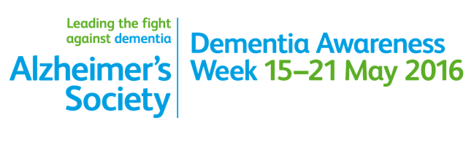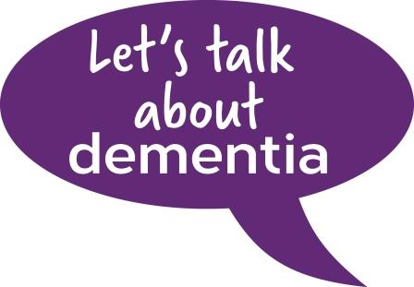

**Wed 24th October.**

**Acocks Green Library**

**Shirley road, Acocks Green.**

**Sponsored by MMP Dudley Park Medical Centre PPG**

**9.30am – 12.00**